Savannah Saavedra

**Critical Introduction for Final Project**

The idea for my final project came from one I worked on last semester in Dr. Schifani’s Media Studies and Digital Humanities seminar, in which I worked with a classmate to find information regarding social media use among Cubans, which included activists, influencers, businesses and independent journalists. We put our data into Qualtrics, a survey tool, in order to analyze our findings. Essentially, we answered the survey as if we were each person, stating what social media accounts they had, which province or city in Cuba they lived in, and what their occupation was of the categories previously listed. I really enjoyed this project, because we were able to visually see the data and get a sense of the access people had to different social media platforms, and where these activists mostly lived in the country. Not only did this project fuel my interest into looking at social media use among activists and protests post July 2021 in Cuba, but also a seminar I took this semester regarding visual art and performance in Latin American social movements, along with the role of social media in propagating this art, as a form of resistance. We thoroughly discussed the use of different social media platforms in current and recent protests in Latin America, especially since the widespread protests thar rocked the region from 2019 onwards. I became interested in how teenagers as young as 14 or 15 years old braved the streets to showcase police brutality on up and coming platforms, such as TikTok, or using hashtags and Facebook lives to call people to meet in a certain place to protest or even share their cause with people around the world. Previously, I thought of social media platforms as more of a frivolous way to share pictures or funny videos, but this century has proved that social media is our way to share news, whether fake or not.

Therefore, I wanted to expand my scope for this project. I originally considered looking for social media use among 50 activists for a total of five to six Latin American countries. Eventually, I decided to stick with 20 activists/politicians for a total of five countries. In the end, I thought 100 people would be a decently sized data set to work with, but I think it would be even more useful to continue this project by looking at an even larger data set among more countries and activists. In order to find the information for each activist, if I was not familiar with an activist to start with, I did a quick Google search to find at least one name of a current activist in each country. For example, I was not very familiar with the current activists in Argentina, so I looked for names on Google, and I found a few to start with. This presented one of my first problems in colleting my dataset, in that some lists provided names of historic activists in the country, so many either lived many years ago or are no longer active. Once I found someone, I searched their name on Twitter, which then provided me with other recommended pages. If I was not sure if someone could be considered an activist or not, I did a brief Google search for their biography as well, to get a sense of who they were or their political platform. I ended up finding a lot of more well-known activists, including many politicians in each country. Although I know that a lot of these more high-profile figures probably have a team that controls their social media accounts, at least I could get a sense of which are more popular in each country, and who is represented on these platforms. I was pleased to find a few Indigenous activists that have very active social media pages with thousands of followers. This is a particular problem in Latin America, where many environmental and social activists in the Afro-Latino and Indigenous communities are murdered every year.

Furthermore, after finding a name to work with, I searched five social media platforms to see if they had accounts or not. Even if some of the less-famous activists did not have many followers on a certain platform, or seemed to only be semi-active on one or two, if I found an account for them, I counted it regardless of number of followers or amount of content available. Many of the accounts I found were verified, so it was easy to confirm if it was them or not. There were only a few instances where someone may not have had verified accounts or ones with a large following to easily identify them, so it was hard to clearly identify if it was indeed the person I was searching for or not, especially if they had a particularly popular name. In these cases, which were not frequent, I had to use my own judgment whether or not to count it. I put all of the data on my spreadsheets, with columns including the name of the person, and the social media platforms they use, along with the province/city they currently live in. Most of the time the place where they live was easy to find, because they mentioned it in their Twitter description, however, if I couldn’t find it there or online, I put a question mark next to where they most likely live based on their occupation (like if they are the mayor of Buenos Aires, foe example) or the city where I discovered they grew up in. I originally only wanted to include people who specifically identified themselves as activists, but I also ended up including politicians as well, many of which are committed to certain social causes, such as Francia Márquez Mina, the first Black woman to be the vice-presidential nominee for the upcoming Colombian elections, who also happens to have a long career as an environmental activist and feminist in her community.

# After collecting the data, I manually counted how many used Twitter, Facebook, Instagram, YouTube, or TikTok in total. I made bar graphs and pivot charts to interpret the data. I decided bar graphs would be a visually appealing way to see the five social media platforms stacked against each other, and the pivot charts were used to mainly show activists per city or province. Likewise, I wanted to incorporate another visual element into my project, so I decided to use Google Maps to visually show where all these people live. I put a marker on the map for each time a city/province came up, so there are several dots for cities/provinces like Havana or Bogota or Buenos Aires. This way, you can see just how much these cities came up, most of which are capitals. Ideally, I would have liked to find more activists from smaller towns and lesser-known regions, but for time’s sake, I had to go with what I could easily find. Perhaps for a future project or independent study, I would like to specifically look at Afro-Latin and Indigenous activists, along with the languages they use and the cities they live in. Which brings me to my next point; I originally wanted to include which language was used by each activist, but this just ended up being the obvious choices of either Spanish in the predominantly Spanish-speaking countries, or Portuguese in Brazil. This idea to study language was also fueled by an article I came across in the *Journal of Open Humanities Data*, “Accessibility, Discoverability, and Functionality: An Audit of and Recommendations for Digital Language Archives.” Although this does not specifically discuss the issue of language inclusion and diversity among social media in Latin America, but digital language archives and accessibility of Indigenous languages in the U.S., the same issues can be applied in the Latin American context with Indigenous languages as well. The article specifically addresses accessibility of digital language archives and the “upkeep of digital infrastructure,” which is an issue I have considered with my project as well.

# As we have discussed extensively in class, online website and platforms are ephemeral. I have seen this phenomena in the social media platforms that were once popular which have now disappeared. For example, I have friends just a few years older than I, maybe a decade at most, who have talked about having Myspace accounts or using iPod, which I never really used because it was just before my time, but even in a span of just five years a social media platform can go out of fashion and all the information along with it. I wonder what may happen to the documentation of these protests, their solid following, and artistic expression that is archived on these platforms. Perhaps before everything became so digital, we could have archived more information in newspapers, books, or magazines, but, who will keep the record of a Facebook live video or a hashtag when Facebook and Twitter become oblique? Or when YouTube no longer houses videos from around the world as it does now? I hope that there is a way to bring scholars, activists and students together to archive their experiences and stories that are now documented in the digital world. Perhaps this is where projects documenting social media come into play, to have a record of how these platforms were used and what this revealed about a current social or political situation of the time.

# This is where I hope the significance of my dataset comes in. Although this project is just a sliver of the work I would like to do one day, it is the beginning of an investigative analysis as to how social media impacts the world we live in, not just to connect our globalized world to share pictures or videos, but to connect as one global consciousness. As I mentioned in my presentation, I have not come across a specific dataset of social media use among activists and politicians in the Latin American region. However, there are several scholars who have studied how social media is used to enact social change or raise awareness in Latin America, especially in the past decade or so. Scholars such as Bernardo Gutiérrez and George Yudice, of our own Modern Languages and Literatures Department, have studied the role of social media use in Latin America. Specifically looking at the research Gutiérrez has done, I was inspired to do some form of mapping for my final project. Although using Google Maps is far simpler than the intricate mapping of social media hashtags he has worked with, I would like to learn to use the technologies he uses, such as his project to map the prevalence of certain hashtags on social media in relation to the 43 students from Ayotzinapa, Mexico who disappeared in 2014, along with the support of student activist groups like “#Yosoy132” or “#Iam132.” This sort of data mapping reminds me of certain features on Voyant that can visually provide connections between data. One can see how certain hashtags are used to bring awareness to social causes, and which ones are most important to the Mexican people, which, in turn, have become global calls to justice as well. As part of my seminar on social media, social movements, and art in Latin America, we have read extensively about scholars who determine what role social media plays in our current global climate, but I have not seen any data collection like I did for this project. Similarly, in other internet searches I have done regarding social media use in Latin America, many have numbers on the percentage of citizens that may use a certain platform or have internet access, but none are as specific as to look at particular activists, politicians, or influencers to analyze their social media use, and where they are located in their country. Furthermore, this issue of access to the internet is one of the problems of this type of project I would like to address, as well as the issue of the political situation and freedom, or lack thereof, of expression each country has.

# Although we live in a 21st-century global context, where literally the world is at our fingertips, there is still a large percentage of people in the world who do not have access to the internet. On the Data World Bank’s website, it claims that 86% of Argentina’s population used the internet in 2020, 81% of Brazil, 88% in Chile, 70% in Colombia, and 72% of Cuba’s population. Although the majority of people have access to the internet now, it doesn’t mean it is always reliable, and many may not even know about all these platforms. However, judging by the fact that the majority of activists and politicians I found use most, if not all of them, shows there is an increasing awareness that social media is a critical tool to reach the masses. Another question, besides access to internet, was the languages used on these social media pages. I did include a few Indigenous rights activists and environmentalists in my dataset, but since many of them are congressmen and women representing their communities, most of their information was in Spanish or Portuguese, depending on the country. They have to use the majority language in order to advocate to lawmakers about their communities needs, but I think it would be interesting to see accounts in certain Indigenous languages very prevalent in Latin America, such as Nahuatl in Mexico, used as a way to connect more people from their communities that may not be completely proficient in Spanish, which is a particularly challenging issue in countries like Guatemala or Peru as well, where there is a decently-sized population that speaks Indigenous languages, like Cakchiquel or Quechua.

# It is also important to take into account the political situation in each country. To note the most obvious example, activists and even everyday citizens in Cuba, are censored by the government. Being an activist in Cuba is extremely dangerous, and often leads to incarceration or exile. This precisely brings up a list of issues I had in finding some of the Cuban activists on social media, in that some did not have accounts on certain platforms or some were in exile, so it was difficult to find their current location. However, although certain platforms were not as prevalent among Cuban activists as in other countries, such as Twitter, some activists use social media presence as a form of personal security. For example, artist and activist, Tania Bruguera, is one of the most famous Latin American artists in the world, and very openly criticizes the Cuban regime through her art and performance. By having such an active following, she is still allowed to come and go out of Cuba, without being forced into permanent exile or incarceration like her peers, because she is so popular. The government does not want to risk international outcry if something were to happen to her, even if she is likely the most hated artist by the Castro regime. Many other well-known artists, such as Luis Manuel Otero Alcántara are facing jailtime, and even if they aren’t present on a certain platform, like Twitter, their colleagues use the platform to raise awareness about the injustices they face by sharing hashtags to inform everyone about his situation.

# One of my main curiosities for this project was to determine if there is a platform more popular in a particular country than another or if across various countries one stood out more. Overall, it seems that Twitter and Facebook are the most popular across the board, followed by Instagram, YouTube, and TikTok. This was to be expected, as it is easier to maintain a Facebook or Instagram account than to upload and create content on YouTube. Likewise, TikTok is so new that many people may not know how it works or why it’s useful. Surprisingly, however, more Cuban activists used TikTok than in other countries, or not as many of them had Twitter, but Facebook was very popular. Although Facebook was previously banned on the island, now it is used by nearly everyone to connect with family, as internet is now more easily available although sometimes unreliable), and most people have a phone. I expected to find more people living in the country’s capital, since most activists and politicians station themselves in the political hub of the nation. This project, as previously mentioned, also made me think about accessibility to more rural communities and groups that have been historically marginalized, who now have the opportunity to have their voices heard.

This reminds me of the reading, “Difficult Heritage and the Complexities of Indigenous Data” by Jennifer Guiliano and Carolyn Heitman. They mention a critical point in the problematics scholars face when studying Native American or Indigenous communities,

“For scholars working in Native American and Indigenous communities (as well as other minority communities) data can be dangerous. Data have been used to promote policies of genocide, inflict trauma, and fragment communities, all of which have had far-reaching consequences across generations. In this article, we explore data related to Indigenous peoples as a multiplicity of data cultures. We highlight how theories of difficult cultural heritage and survivance trouble the dominant, normative data culture within which most humanities researchers operate” (2).

This concept is important to keep in mind, in that now Indigenous leaders are able to share their community’s needs and struggles through more political representation, and through social media. Thus, they now have somewhat more agency to share their own stories, trials and tribulations with the world, whereas before many White scholars or racist institutions would take the liberty of speaking on behalf of them. This concept of “difficult heritage,” speaks directly to this notion that the dominant racial group, in terms of historically who has held the most power and representation, which are usually those of European descent in countries who have a colonial past, feel uncomfortable with coming to terms with the truth. Indigenous rights groups and community leaders have trouble finding an audience to listen to their stories and traumas because they are “uncomfortable.” However, with the gift social media provides us to share videos and photos automatically for the whole world to see, or to gather community support through a common page for a cause or community, they can share these views and take this to the courts. I believe all of the Indigenous activists I found are also politicians, which shows that getting into politics is the best way to advocate for change in their communities, which speaks to the fact that their histories are no longer curated in a museum by those who gain from their oppression, but they are the ones curating the narrative of their people’s past, present, and future struggles.

Overall, this project has provided me with a fruitful start in examining the use of social media in Latin America. I would love to expand my scope to other countries, as well as incorporate other technologies to interpret the data I find. I was able to get a sense where most activities live and how language is used among them. I was also able to see that, although Internet access is not available to everyone, the stereotype that internet access is very limited to many of these countries is a myth, especially the increasing use of social media in Cuba, where this was only in their wildest dreams decades ago. Data in social media can be both a dangerous and empowering tool, as Giuliano and Heitman mention, but community leaders can gain support and raise awareness through these platforms. I think of Marielle Franco, an Afro-Brazilian activist who was killed in 2018, whose legacy continues on social media through her sister’s activism and her organization’s mission to keep her legacy alive by managing her accounts. Her story serves as an example of an activist who feel victim to state oppression and violence, but her efforts do not go down in vain, as her memory lives on in film, social media hashtags and videos, as well as community organizations that are fueled by the impunity of her murder. Her sister, a fellow activist, uses social media to share her story and continue to remind people that they have never found those responsible for her murder, but that her memory lives on through community engagement in the favelas she gave her life to protect. Perhaps certain platforms will eventually disappears, but I hope the habit of sharing a global consciousness of what is being done to make the world a better place continues on whatever platform may exist in the future. That is social media’s true power, not the platform, but the medium it provides to connect us all; perhaps McLuhan was right in that the medium is the message. (The following image is an example of Gutierrez’s mapping of certain hashtags related to social movements in Mexico).

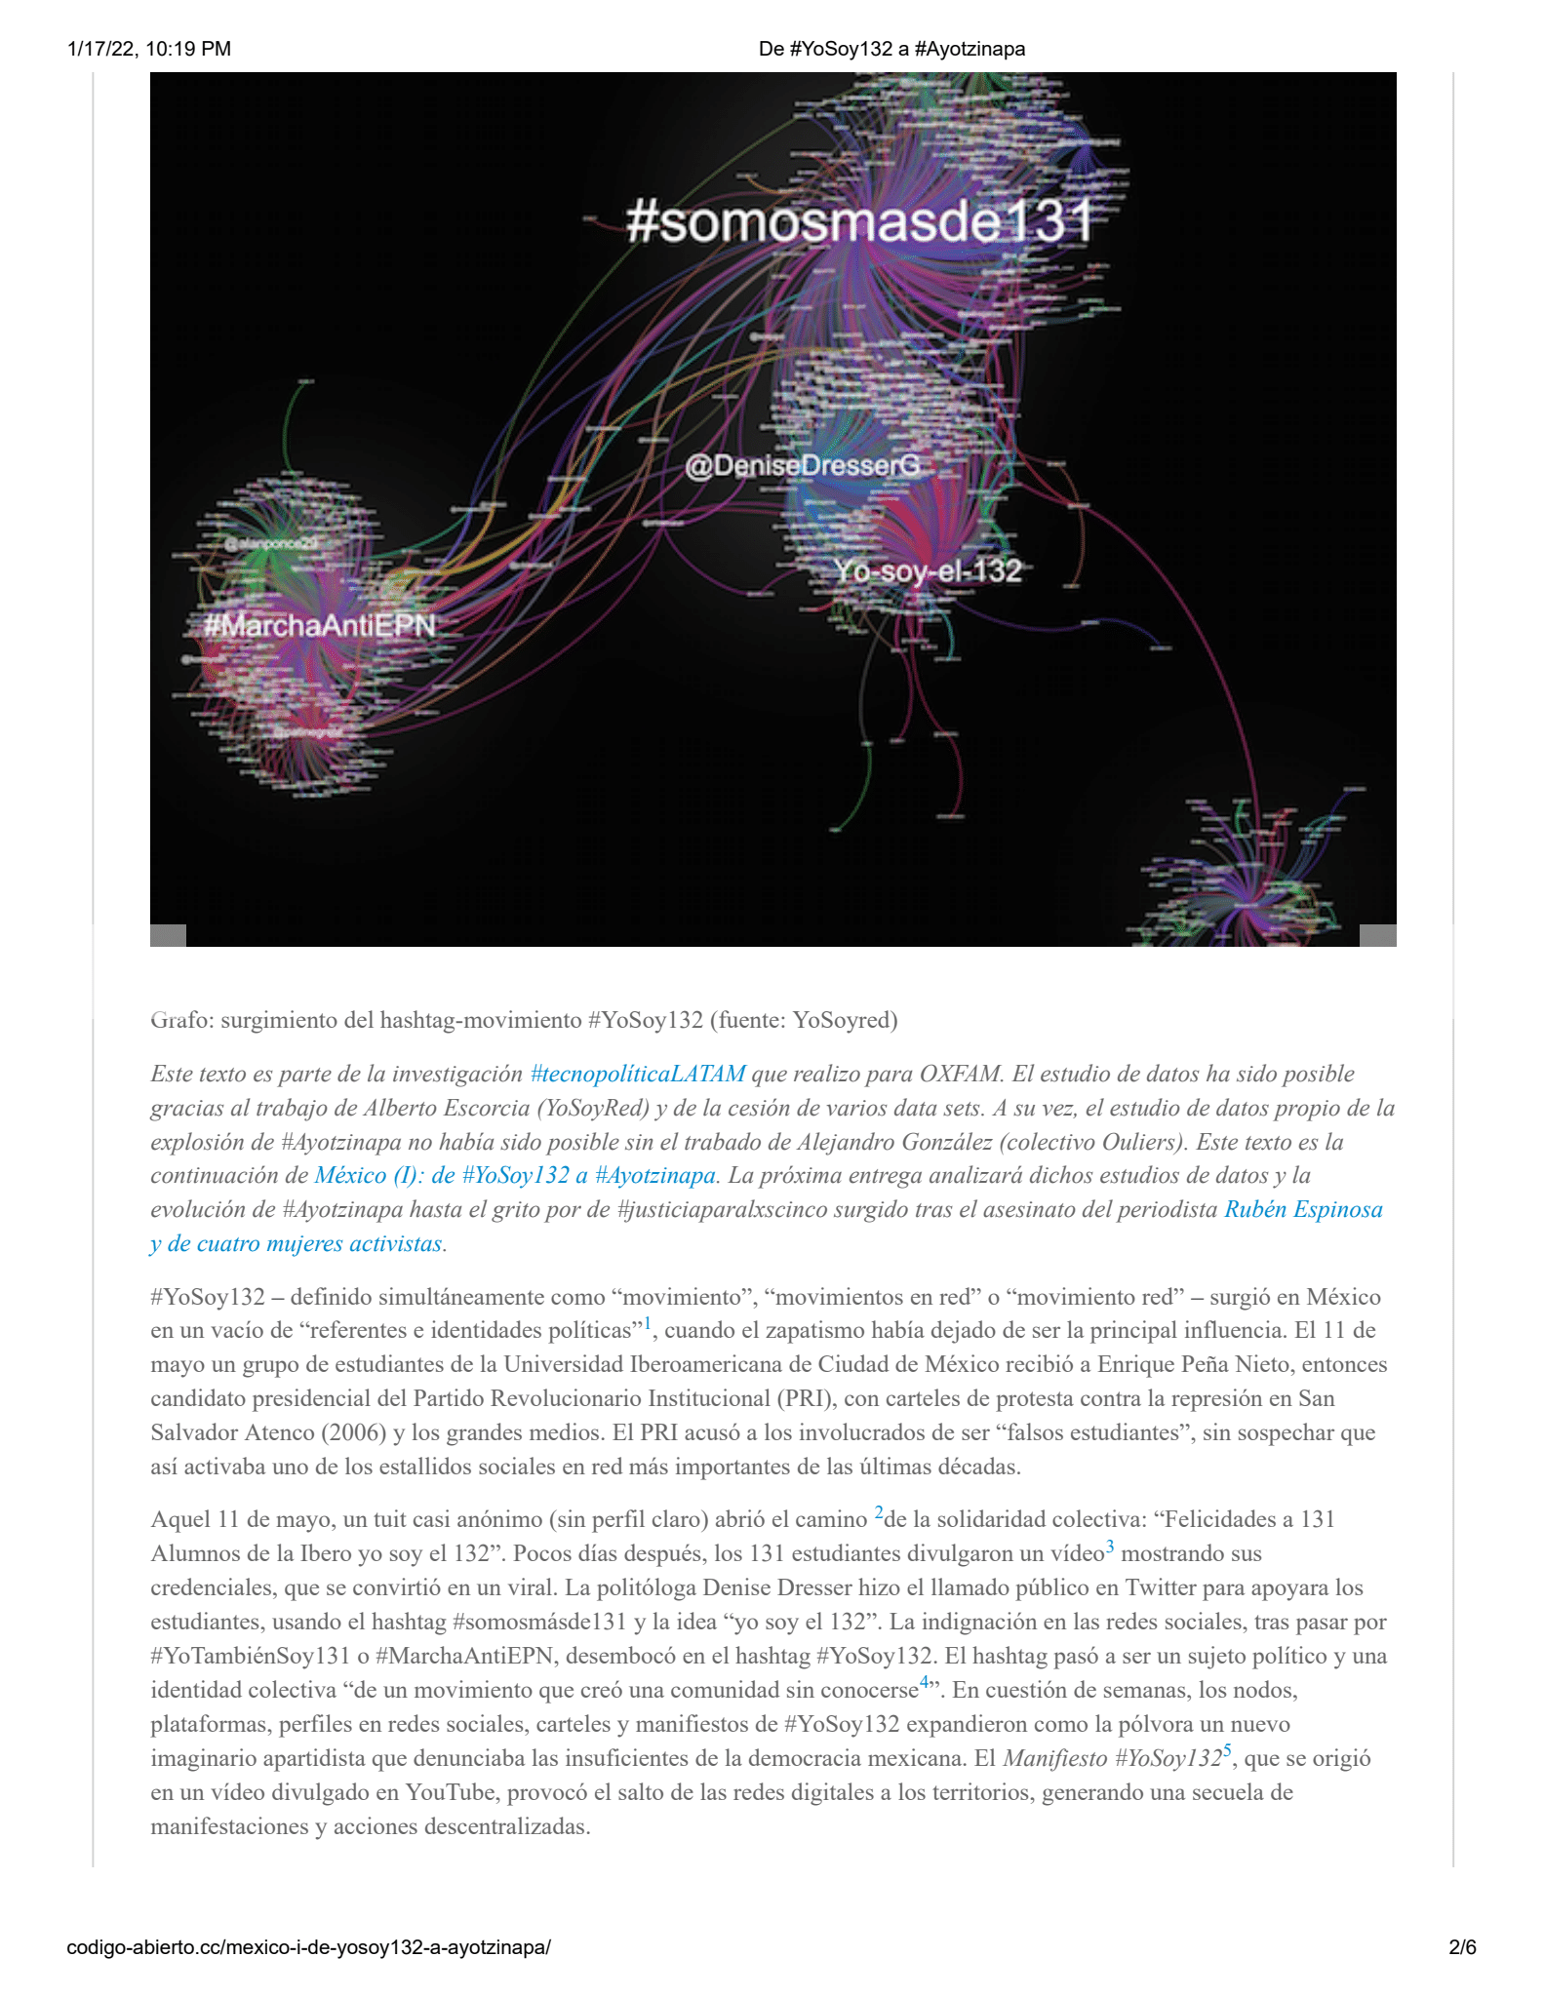

Works Cited

Guiliano, Jennifer, and Carolyn Heitman. 2019. “Difficult Heritage and the Complexities of Indigenous Data.” *Journal of Cultural Analytics* 4 (1). <https://doi.org/10.22148/16.044>.

Gutierrez, B. (2015, April 6). *Ayotzinapa, La expansión global de una causa*. #CódigoAbierto_CC. Retrieved May 10, 2022, from http://codigo-abierto.cc/ayotzinapa-la-expansion-global-de-una-causa/

Gutierrez, B. (2015). *#YOSOY132 denuncia La Democracia Ausente en México*. #CódigoAbierto_CC. Retrieved May 10, 2022, from https://codigo-abierto.cc/yosoy132-denuncia-la-democracia-ausente-en-mexico/

Individuals *using the internet (% of population) - latin america & caribbean, Colombia*. Data. (n.d.). Retrieved May 10, 2022, from https://data.worldbank.org/indicator/IT.NET.USER.ZS?locations=ZJ-CO

Yi, I., Lake, A., Kim, J., Haakman, K., Jewell, J., Babinski, S., & Bowern, C. (2022). “Accessibility, Discoverability, and Functionality: An Audit of and Recommendations for Digital Language Archives” *Journal of Open Humanities Data*, *8*, 10. DOI: <http://doi.org/10.5334/johd.59>